Case1: Company system – UNF table  
  
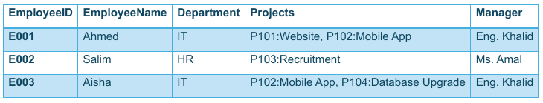

▪ Convert to 1NF (atomic values only)

|  |  |  |  |  |
| --- | --- | --- | --- | --- |
| Company | | | | |
| EmployeeID | **EmployeeName** | **Department** | **Projects** | **Manager** |
| E001 | Ahmed | IT | P101: Website | Eng. Khalid |
| E001 | Ahmed | IT | P102: Mobile App | Eng. Khalid |
| E002 | Salim | HR | P103: Recruitment | Ms. Amal |
| E003 | Aisha | IT | P102: Mobile App | Eng. Khalid |
| E003 | Aisha | IT | P104: Database Upgrade | Eng. Khalid |

▪ Convert to 2NF (no partial dependency)

|  |  |
| --- | --- |
| Employee | |
| EmployeeID | **EmployeeName** |
| E001 | Ahmed |
| E002 | Salim |
| E003 | Aisha |

|  |  |  |
| --- | --- | --- |
| Department | | |
| DepartmentID | **Department** | **Manager** |
| 1 | IT | Eng. Khalid |
| 2 | HR | Ms. Amal |

|  |  |
| --- | --- |
| Projects | |
| ProjectID | **ProjectName** |
| P101 | Website |
| P102 | Mobile App |
| P103 | Recruitment |
| P104 | Database Upgrade |

|  |  |
| --- | --- |
| Employee_Department | |
| EmployeeID | **DepartmentID** |
| E001 | 1 |
| E002 | 2 |
| E003 | 1 |

|  |  |
| --- | --- |
| Employee_Project | |
| EmployeeID | **ProjectID** |
| E001 | P101 |
| E001 | P102 |
| E002 | P103 |
| E003 | P102 |
| E003 | P104 |

▪ Convert to 3NF (no transitive dependency)

|  |  |
| --- | --- |
| Employee | |
| EmployeeID | **EmployeeName** |
| E001 | Ahmed |
| E002 | Salim |
| E003 | Aisha |

|  |  |  |
| --- | --- | --- |
| Department | | |
| DepartmentID | **Department** | **Manager** |
| 1 | IT | Eng. Khalid |
| 2 | HR | Ms. Amal |

|  |  |
| --- | --- |
| Projects | |
| ProjectID | **ProjectName** |
| P101 | Website |
| P102 | Mobile App |
| P103 | Recruitment |
| P104 | Database Upgrade |

|  |  |
| --- | --- |
| Employee_Department | |
| EmployeeID | **DepartmentID** |
| E001 | 1 |
| E002 | 2 |
| E003 | 1 |

|  |  |
| --- | --- |
| Employee_Project | |
| EmployeeID | **ProjectID** |
| E001 | P101, P102 |
| E002 | P103 |
| E003 | P102, P104 |